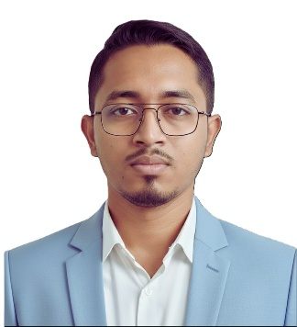
MOHAMMAD SHOIKOT

Phone: +8801975969233 | Email: shoikot233@gmail.com

Address: House: Cox’s Bazar, Bangladesh

EXPERIENCE
- Teaching & Classroom Management
- Leadership & Team Supervision
- Communication & Interpersonal Skills
- Time Management & Organization
- Problem Solving & Decision Making
CORE SKILLS

Assistant Teacher
Anonda Multimedia School & College, Cumilla
📅 Jan 2024 – Dec 2025
Key Responsibilities:
- Delivered structured lessons and ensured student engagement
- Evaluated student performance and maintained academic records
- Assisted in curriculum planning and classroom management
- Maintained communication with students and guardians

Senior Teacher
Chakaria Matamohuri Dhakil Madrasha, Chakaria
📅 Jan 2022 – Dec 2024
Key Responsibilities:
- Conducted subject-based teaching with effective lesson planning
- Monitored student progress and provided feedback
- Supported institutional academic activities
- Maintained discipline and classroom environment

Vice Principal
Sawtul Quran International Madrasha, Cox’s Bazar
📅 Jan 2025 – Dec 2026
Key Responsibilities:
- Supervised academic and administrative operations
- Managed teaching staff and coordinated schedules
- Ensured quality education and institutional discipline
- Assisted in policy implementation and development

ABOUT ME
Motivated and dedicated professional seeking a challenging position in a disciplined and growth-oriented organization where I can utilize my teaching, communication, and leadership skills to contribute effectively while continuously developing my professional capabilities.

TRAINING
- Basic Computer Training (3 Months)
Computer Learning Center

- Dawraye Hadith
Jamia Darul Ma’arif, Chittagong
GPA: 5.00 | Year: 2022
- Fazil (BTIS)
Islamic Arabic University
GPA: 3.50 | Year: 2021
- Alim (Arts)
Cox’s Bazar Hashemia Kamil Madrasha
GPA: 3.94 | Year: 2018
- SSC (Arts)
Khorolia Talimul Quran
GPA: 3.98 | Year: 2016
EDUCATIONAL QUALIFICATIONS

TECHNICAL SKILLS
- MS Word, Excel, PowerPoint
- Adobe Photoshop & Illustrator
- Internet Browsing & Email Communication
- Office Management

- Bangla: Excellent (Reading, Writing, Listening, Speaking)
- English: Good (Reading, Writing, Listening, Speaking)
- Chittagonian: Fluent

LANGUAGES

PERSONAL INFORMATION
- Father’s Name :
- Mother’s Name :
- Religion : Islam
- Date of Birth : 03rd April 2003
- Nationality : Bangladeshi
- Gender : Male
- Marital Status : Unmarried
- Blood Group : O+
- National Id :
- Permanent Address : Vill: Bahaddar kata, P.O: Chakaria, P.S: Chakaria, Dist.: Cox’s Bazar.

DECLARATION
I hereby declare that all the information provided above is true and correct to the best of my knowledge.

Mohammad Shoikot

