Mohammad Shoikot
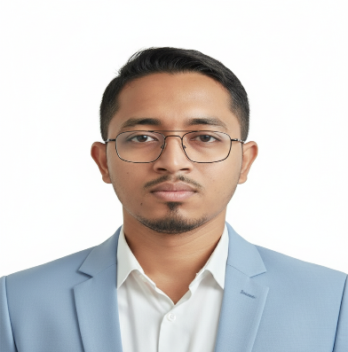
CEER OBJECTIVE
To build a dynamic and challenging career where I can effectively utilize my technical and interpersonal skills, creativity, and learning experience to contribute to organizational success while achieving professional growth.

EDUCATION

Master of Business Administration (MBA) in Accounting
National University
Azam khan Commerce College, Khulna
Passing Year: 2022 (Session: 2019, delayed due to COVID-19)
Result: CGPA 3.03 out of 4.00

Bachelor of Business Administration (BBA) in Accounting
National University
Ahsanullah College, Jessore Board
Passing Year: 2019
CGPA: 3.29 out of 4.00
Higher Secondary Certificate (HSC) – Commerce
Rupsha College, Jessore Board
Passing Year: 2014
GPA: 3.90
Secondary School Certificate (SSC) – Commerce
Naihati Secondary School, Jessore Board
Passing Year: 2012
GPA: 3.88
CONTACT

Dhaka

+8801975 969233

shoikot233@gmail.com

SKILLS
- Self-motivated and hardworking
- Strong team player with leadership ability
- Target-oriented and result-driven
- Positive mindset with good communication skills
- Adaptable and quick learner

- Microsoft Office (Word, Excel, PowerPoint)
- Data Entry
- Email & Internet Browsing
- Basic Research Work

COMPUTER SKILLS


PERSONAL INFORMATION

- Father’s Name :
- Mother’s Name :
- Date of Birth : 10 November 1996
- Nationality : Bangladeshi (By Birth)
- Sex : Male
- Marital Status : Married
- Religion : Hindu
- Blood Group : O-
- Height : 5.7"
- Weight : 64 kg
- National ID :
- Permanent Address : Bhaluka, Mymenshing

LANGUAGE
- Bengali: Native
- English: Good (Speaking & Writing)

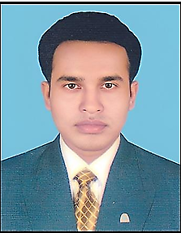
- Able to adapt quickly to new and challenging situations
- Strong communication skills with pleasant personality
- Capable of working in any environment

DECLARATION

PERSONAL STRENGTHS

I hereby declare that all the information provided above is true and correct to the best of my knowledge, and I take full responsibility for the accuracy of the information.

Mohammad Shoikot

I hereby declare that all the information stated above is true and correct to the best of my knowledge and belief.

Habibur Rahman

